# How to be in the top 1% in 2024

## 8 habits to help you be a better version

[[smoul](https://medium.com/@moulshree?source=post_page-----92266c1fe7ab--------------------------------)](https://medium.com/@moulshree?source=post_page-----92266c1fe7ab--------------------------------)

[[Practice in Public](https://medium.com/practice-in-public?source=post_page-----92266c1fe7ab--------------------------------)](https://medium.com/practice-in-public?source=post_page-----92266c1fe7ab--------------------------------)

[smoul](https://medium.com/@moulshree?source=post_page-----92266c1fe7ab--------------------------------)

·

[Follow](https://medium.com/m/signin?actionUrl=https%3A%2F%2Fmedium.com%2F_%2Fsubscribe%2Fuser%2Ff94b3cba03dc&operation=register&redirect=https%3A%2F%2Fmedium.com%2Fpractice-in-public%2Fhow-to-be-in-the-top-1-in-2024-92266c1fe7ab&user=smoul&userId=f94b3cba03dc&source=post_page-f94b3cba03dc----92266c1fe7ab---------------------post_header-----------)

Published in

[Practice in Public](https://medium.com/practice-in-public?source=post_page-----92266c1fe7ab--------------------------------)

·

7 min read

·

Dec 15

4.3K

68



Photo by [Paul Pastourmatzis](https://unsplash.com/@pueblovista?utm_content=creditCopyText&utm_medium=referral&utm_source=unsplash) on [Unsplash](https://unsplash.com/photos/person-standing-on-green-mountain-near-smoke-during-daytime-NZ-K01i0Hmo?utm_content=creditCopyText&utm_medium=referral&utm_source=unsplash)

As the year 2023 comes to an end, most of us a preparing to set goals, and create lists and resolutions for 2024. The new year is not just about the year ending, it is like a goodbye to your old self, the mistakes you made, and the battles you lost all the while hoping for a fresh start with a new year.

If you too are looking to rise above the odds and be in the top percentile — you’ve come to the right place. I’m here not to share the wisdom but only my experience. Why must you listen to me?

Maybe because I was able to defy the odds and achieve that pedestal for myself this year. In 2023, I was working a 4 figure job that was nothing but a wave of unhappiness.

* Waking up like a robot
* Doing the same work knowing there is so little impact
* Going to sleep late
* Not getting enough time to meet friends/family

I had had enough of that in 2023 — which led to a bunch of decisions that I am grateful for even today.

I left my job and stayed unemployed for a good 2–3 months only to land my dream 5-figure job.

* I even started my own Notion and Productivity business
* Grew my social presence to 20,000+
* Started networking with people across the globe and got on calls with founders
* Started a newsletter and finally created passive income alongside my day job

All because I followed a bunch of habits, models, and mentalities. The simplest of them all was

To get head of the 99% of the people, you’ll have to do what the 99% is unwilling to do

Every time you wake you have to ask yourself, “Is this bringing me comfort or is this making me lazy”. Most of the time, the things making me feel the most comfortable were the ones keeping me away from my true potential.

For example, I had a job, that was bringing me money, if I wanted, I would have just stayed there, passed my time, and done my work, and life would have gone smoothly. Only when I decided to challenge the odds and quit, I was able to get a better opportunity. Even then, I leaped to start my own business (all bootstrapped). Which brings us to our 1st habit:

## 1. Seek Discomfort

Sounds cliche, but trust me this one is the most important lesson. Professionally or personally, seeking discomfort is the only way a person can know their potential. Are you too comfortable with your work right now? Challenge it — take more tasks and push your boundaries.

Want to start your business but don’t have time? Make it. Do work while traveling, cooking, an hour before bed — replace your TV time with work time. Let go of the materialistic happiness.

*But that’s like being a robot*

Absolutely not. Like I said, to be ahead of people, you’ll have to do what they’re unwilling to. People in their 20s would party, spend money and buy expensive things, go out each day — there is nothing wrong with that. It is called the life of choice.

Your choices today will decide the future you have tomorrow. I like many others, choose to make sacrifices today so that I can have a more comfortable tomorrow. The hustle is not for the weak-hearted — you have to make up your mindset for it.

This cultivates resilience, adaptability, and a fearless attitude toward challenges.

## 2. Focus on What Matters

It’s not merely about ‘focus’; it’s about honing in on ‘what matters.’ Don’t invest time in things that don’t make you happier, healthier or smarter. Watch a show, eat something healthy, read a book — create a lifestyle that leads to ultimate betterment.

Whether you prefer podcasts over reading or yoga over exercise, don’t squander your energy on activities that don’t align with your authentic self.

Life is too short to engage in things that fail to ignite your excitement. Navigate away from energy-draining influences like social media or celebrity gossip, and invest your time where it truly matters.

## 3. Take Responsibility for Your Life

Life is riddled with challenges, but success begins with taking responsibility. You have the power to shape your destiny. No one is coming to save you or do the tough tasks for you. They won’t get a job for you or start a business for you. It is all you in this game, make each moment count.

Acknowledge flaws, learn from mistakes, and eschew excuses. By taking responsibility, you gain the autonomy to make positive changes and pursue goals with intent.

## 4. Let Go of the Need for Approval

Success often necessitates breaking free from the chains of external validation. The first time I got a good grade, my mother said ‘Good Job’. From that day on, I studied like an owl to get the perfect score only to hear those words of affirmation from my parent. That did more harm than good — because when I don’t hear those words, I won’t be proud of my score.

I started setting up validation expectations only to feel proud about my work.

To surge ahead, abandon the incessant need for approval. So if people congratulate you, feel happy; if they don’t — move ahead.

Forge a path guided by internal validation, accepting yourself — including flaws — and pursuing your goals unapologetically.

## 5. Develop Resilience

Resilience is the cornerstone of personal growth. It entails bouncing back from setbacks, adapting to change, and persisting in the face of adversity.

You’ll have to be comfortable with the idea of failing. For me, whenever I faced a setback, instead of saying ‘I lost’, I just said ‘The experiment didn’t work’.

The strongest person is not the one who never lost, but the one who lost but still got back up. In your journey, there are going to be days when you don’t feel motivated, those are the days when you have to push through and come forth stronger.

By developing resilience, you not only weather challenges but thrive in the midst of them.

## 6. Focus on your habits

People usually ask me

*“How did you know about your business?”*

Well, I didn’t. I had always been a spokesperson for productivity and had been using Notion for years. I was a writer since the age of 10 and even wrote a poetry book. But I never thought of intersecting the two interests.

One day my classmate said “Your templates are so good, I would pay you for them”

Ofc, he was joking but that one sentence I’ll never forget. That was the day I took my Notion board and published it for free — within the first day I had 7 downloads.

You have to focus on your skills and the things that make you happy.

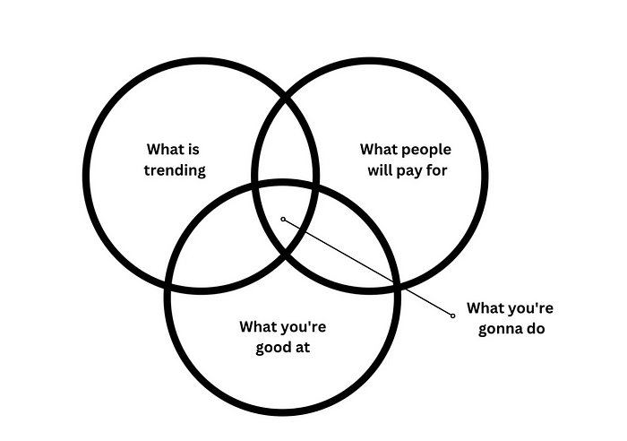

**Picture by Self**

Here is the perfect representation of what can help you make passive income. What is something

* You’re good at
* What people will pay you for
* What is trending/in business

The moment you find the answer to these — you’ve taken the first step in the path.

## 7. Grow a network

Being mysterious and a lone wolf can only get you so far. I used to be so introverted. I had fewer friends and rarely hung out with people. I liked my own company. But when I started sharing my experiences online, so many people reached out. We created a group to interact and boost each other in any way possible.

It was the best circle I had been a part of.

Don’t let your geography keep you from meeting the right people

Portugal, Mexico, France, Austin, etc, I talked to people from all these places and many more. We spent hours talking about our interests, and our motivations and sharing ideas.

As you grow your network, you’ll realize the importance of having the right support.

## ****6. Embrace the journey****

Finding meaning in life is not achieving specific goals or milestones, but rather embracing the journey itself. This means finding joy in the process of growth and self-discovery, rather than focusing solely on the destination.

You need to cultivate a sense of curiosity and wonder about the world, and approach each day with a sense of adventure and possibility. Most people become unhappy in their mid-twenties because they feel aimless. From a young age, our purposes and goals were defined for you

* Go through school
* Get good grades
* Get into a good college
* Get a degree
* Get a job

By your mid-twenties, you are probably done with this cycle and then you are confused because you cannot think for yourself anymore. You have no one to tell you what to do and you think the rest of your life is doing that job and aiming for promotions. You need to embrace that life is all about learning and finding new things. Don’t let a set of rules decide what you can do with your life.

At the end, there is one last thing I want to say:

*Climb mountains not so the world can see you, but so you can see the world — David McCullough Jr.*

When you’re aiming to be better, try to be better than the person you are tomorrow. Work hard, give up the thought of fear, and reach for your goals to make yourself proud.

## Give your dream a chance.

Join the 900+ people already on the list to learn more about becoming productive and starting as a solopreneur. [Decoding Solopreneur](https://notaprodigy.beehiiv.com/)s

Get my guides and productivity notion templates: [Bento](https://bento.me/smoul)